Lab 4
Natnael Kebede
Section 1
- Screen capture showing the PasswordGPO policy settings
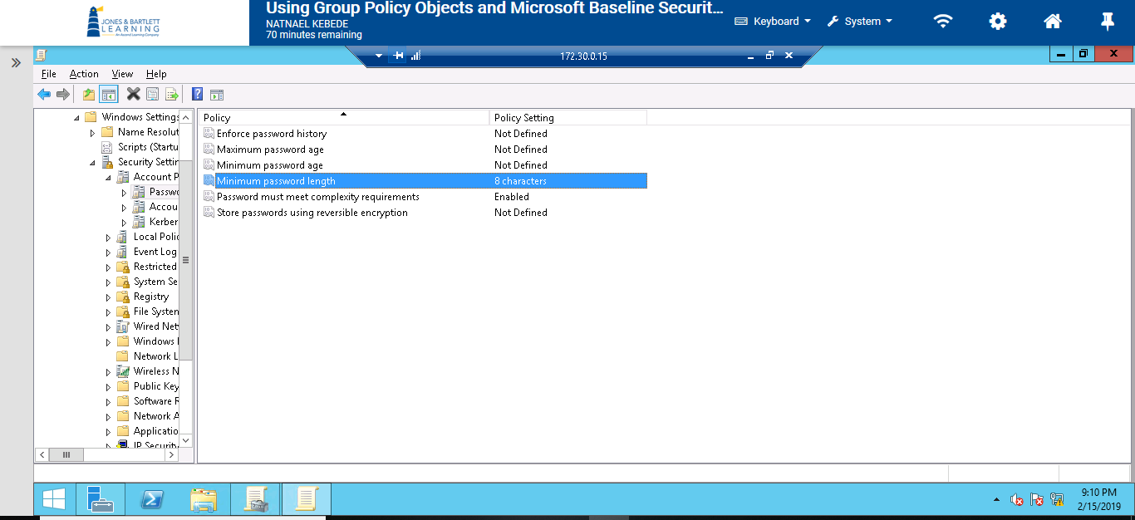
- Screen capture showing the contents of each link for one issue, Password Expiration.
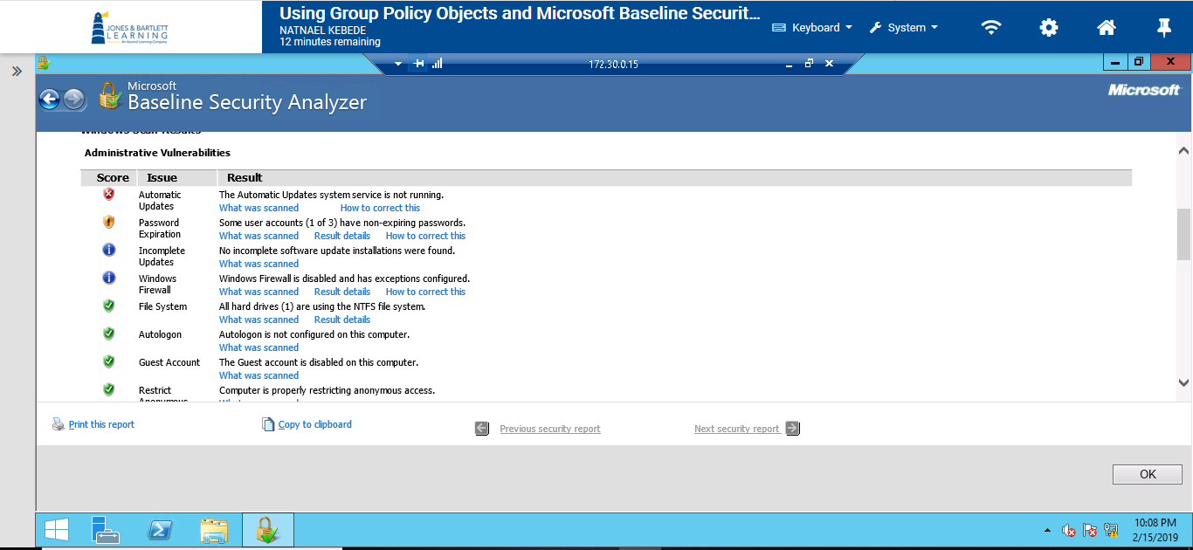

- What was scanned
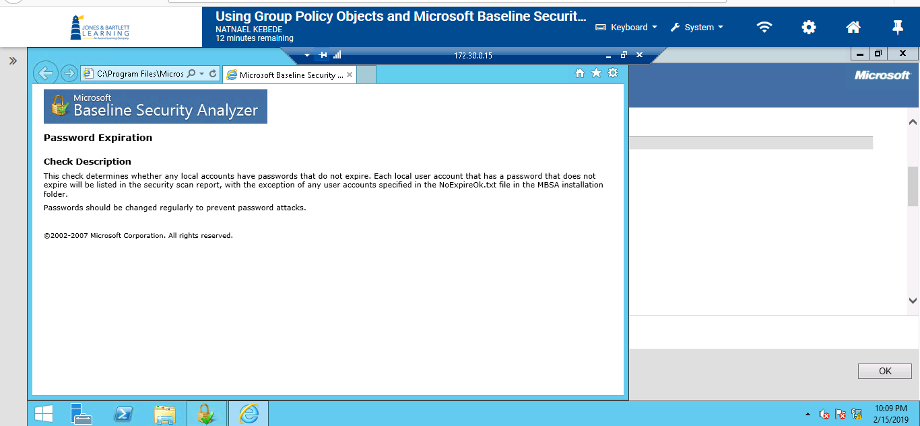
- Result details
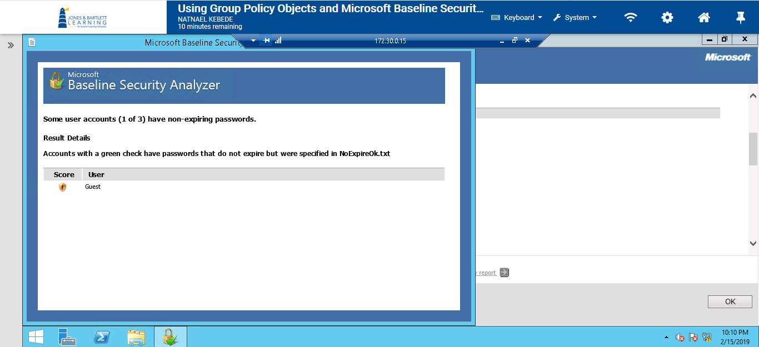

- How to correct this
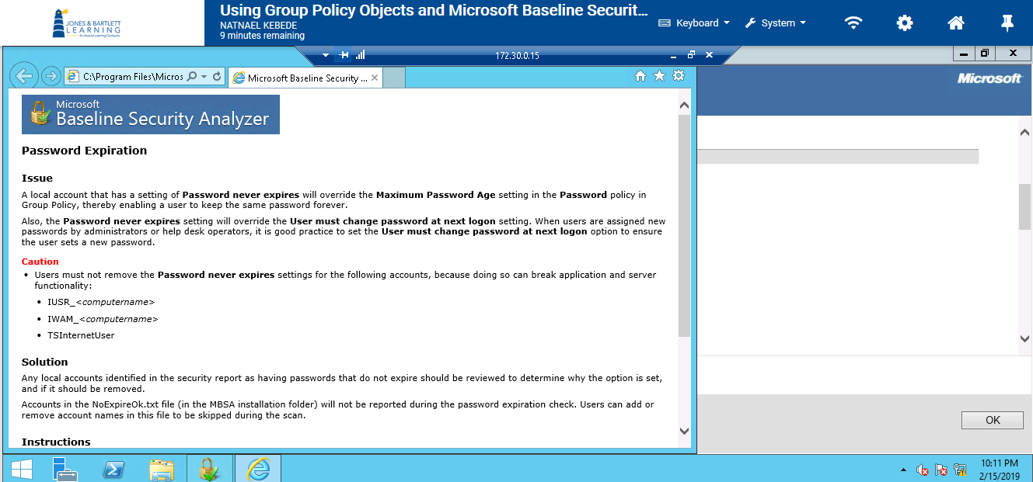
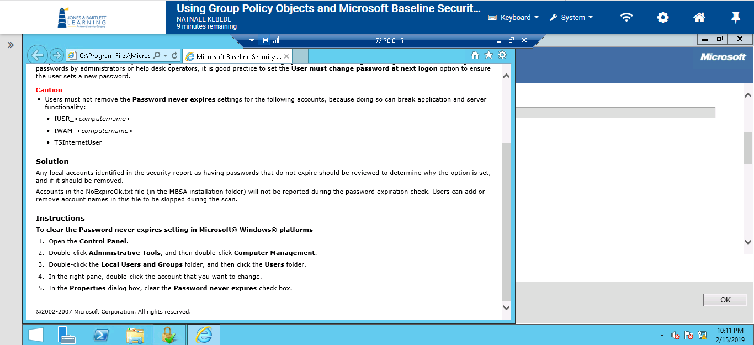

Section 2
- Screen capture showing Natnael_S2_PasswordGPO password configuration that defines password policy that reflects recognized best practices.
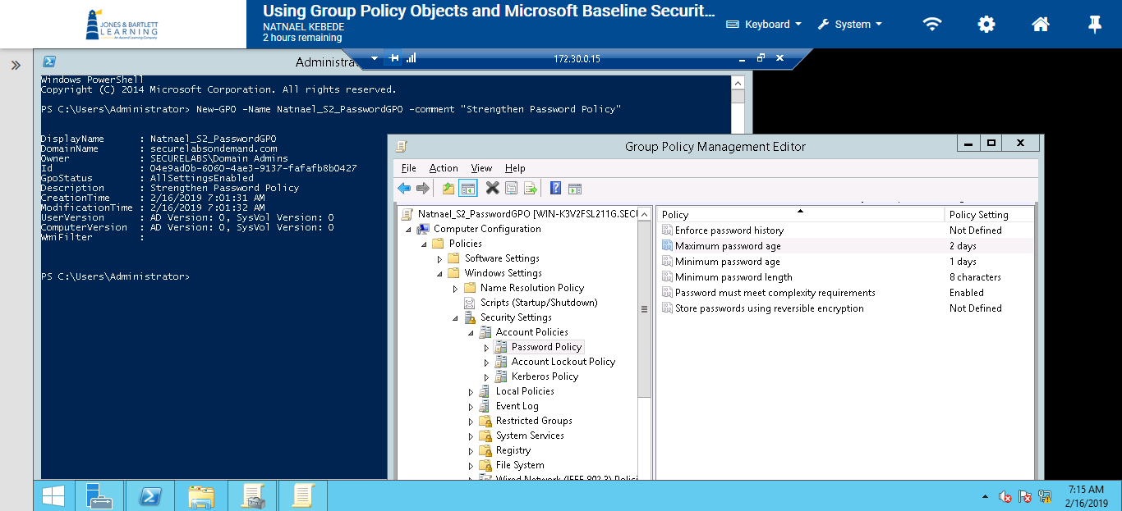
- Screen capture showing the scans performed sorted by scan date (descending)
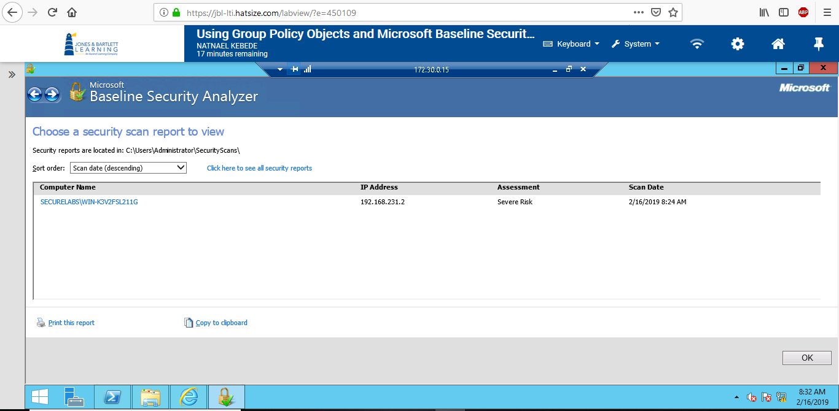

- Screen capture showing the use of recommended changes to correct the failed automatic updates
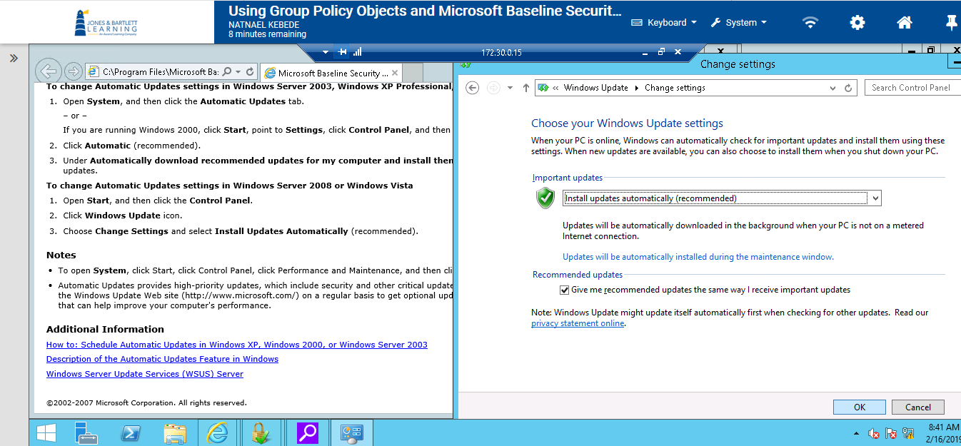
Actions taken eliminated the vulnerability of Automatic updates.
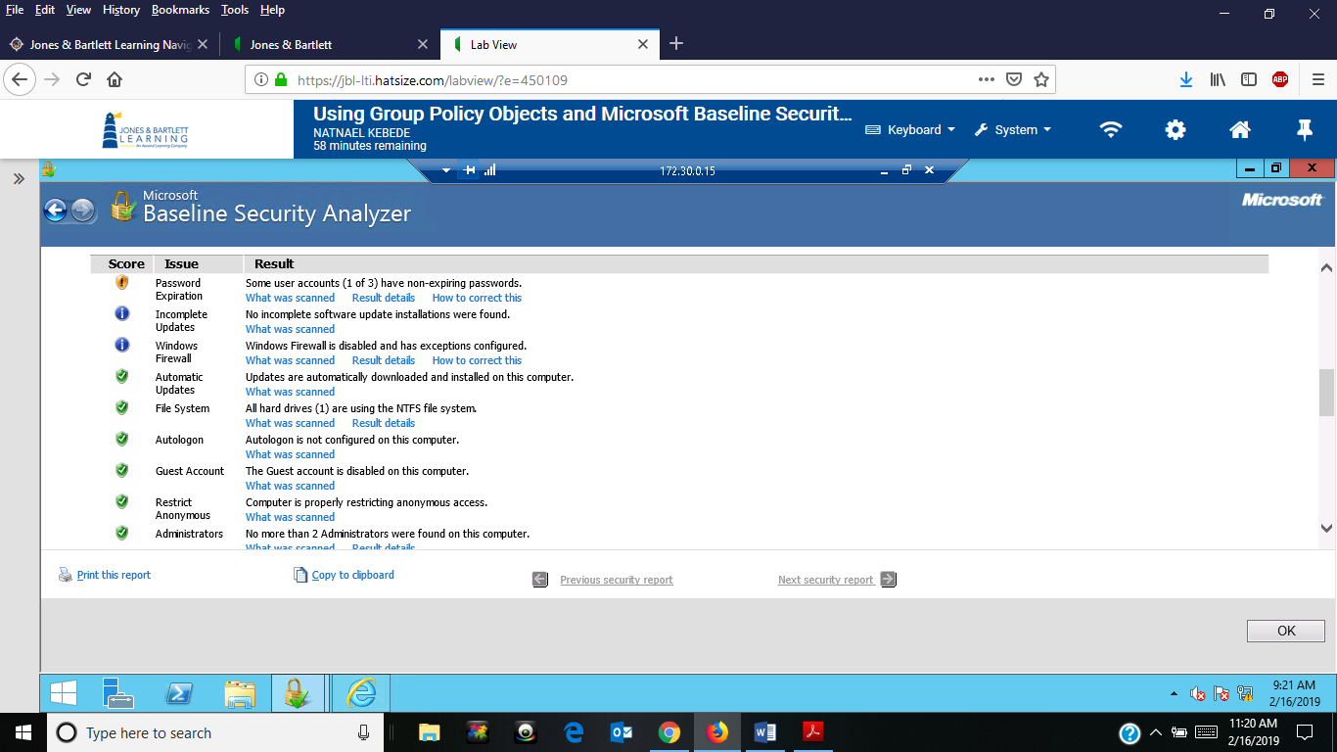

- Screen capture showing the use of recommended changes to correct the failed password expiration.
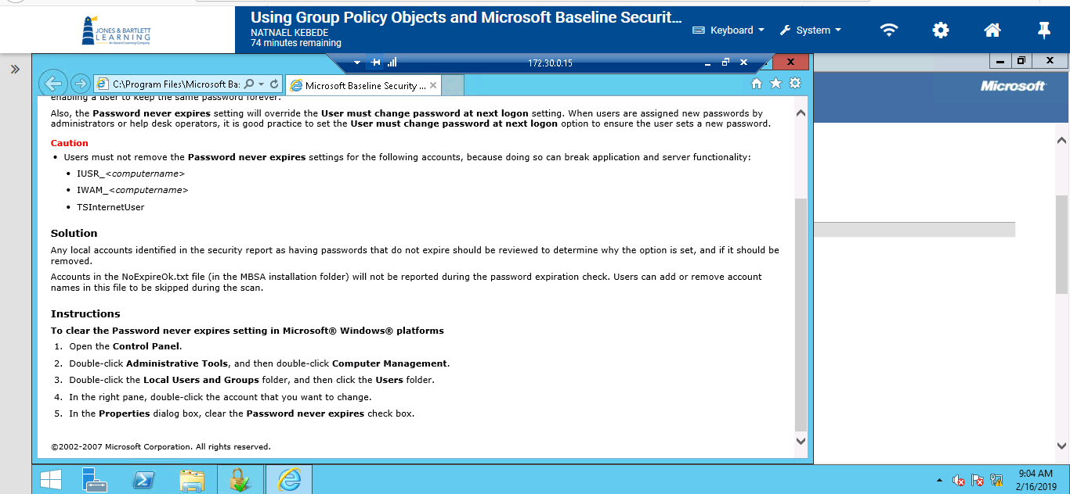
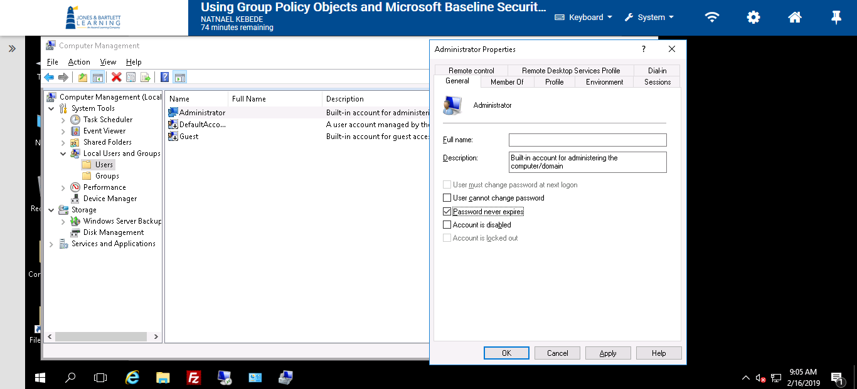

However, actions taken did not eliminate this vulnerability.
